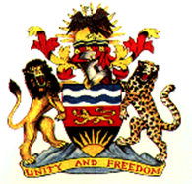 |  | 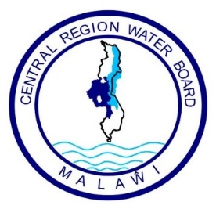
Ministry of Agriculture, Irrigation & Water Development |  | Central Region Water Board

CENTRAL REGION WATER BOARD
INVITATION FOR BIDS
TENDER FOR SUPPLY & DELIVERY OF PUMPS, PIPES & STEEL TANK FITTINGS & ACCESSORIES
PROCUREMENT REFERENCE No: CRWB/G/SA/2026
DATE OF ISSUE: Monday19th October,2026
Central Region water board through the Government of Malawi has received funding under the Public Sector Investment Program (PSIP) toward the cost of the Procurement of the under listed Goods and related services.
Lot 1. ASSORTED PUMPS AND ACCESSORIES
No | Description | Delivery Period | Delivery Point
1 | Assorted Pumps & Accessories | 4 Weeks | CRWB Head office-LL

Lot 2: STEEL TANK FTIINGS & ACCESSORIES
No | Description | Delivery Period | Delivery Point
1 | Steel Tank Fittings & Accessories | 4 Weeks | CRWB Head office-LL

Lot 3: PIPES & FITTINGS
No | Description | Delivery Period | Delivery Point
1 | Pipes & Fittings | 4 Weeks | CRWB Head office-LL

- The Board now invites sealed bids from eligible bidders for the supply and delivery of the above Goods and related services
- Bidding will be done in accordance with the open tendering procedures contained in the Public Procurement Law and Regulations of the Republic of Malawi.
- Interested eligible bidders may obtain further information from and in respect of bidding documents at the address at Nine (9) attention: Acting Procurement & Disposal Manager
- A complete set of bidding documents in English may be purchased by interested bidders upon payments of a non-refundable fee of MWK 10,000(Ten Thousand Kwacha) by cash or Bank certified cheque.
- Bids clearly marked” Tender for Supply and delivery of Pumps, Pipes and Steel Tank Fittings & Accessories must be delivered to the address shown at “9(b)” below on or before Monday 09th November,2026 at 11:00 hours. All Bids must be accompanied by a duly completed bid securing declaration form.
- Late Bids shall be rejected
- Bids will be opened at Central Region Water Board Conference Room on Monday 09th November,2026 at 11:00hours in the presence of bidders ‘representative who choose to attend the bid opening ceremony.
- Central Region Water Board reserves the right to reject any or all bids and is not bound to accept the lowest or any other bidder.
- Addresses referred to above are:
(a)For clarification of Bidding documents
Attention: The Acting Procurement and Disposal Manager
Central Region Water Board
Area 4, Murry Road
Private Bag 59,
Lilongwe
Malawi
Phone No: (+265) (0)310002128
Cellphone: 0999 203 621/0888 903 621
Email: crwb@crwb.mw/tnyalapa@crwb.mw
(b) For submission of Bids
The Chief Executive Officer
Attention: The IPDC Chairman
Central Region Water Board
Area 4, Murray Road
Private Bag 59,
Lilongwe
Malawi

